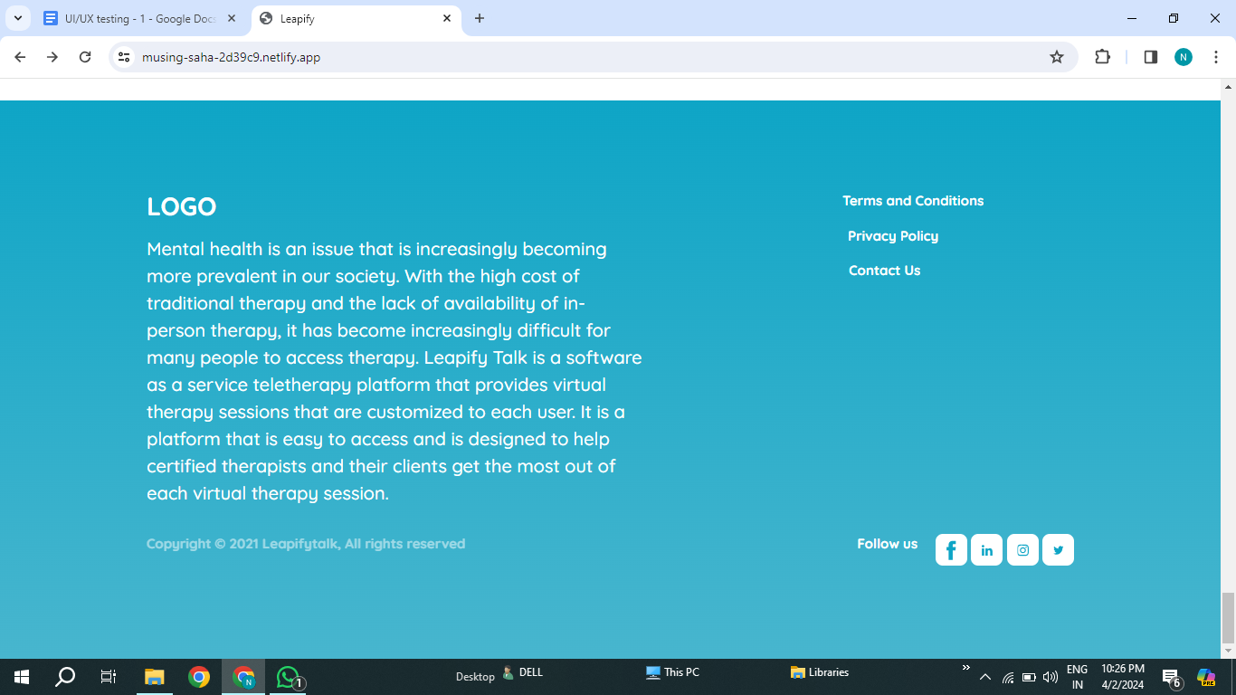

Social media links are not navigating to respective pages or it is not clickable